1. First of all, you will need a thing called openvpn to access the sql database and stuff like that because that’s how the uni decided to do it. So here are links depending on your OS on how to install and use that:

<https://docs.cs.cf.ac.uk/notes/openvpn-windows/>

<https://docs.cs.cf.ac.uk/notes/openvpn-macos/>

1. First of all, obviously you will need python. So if you haven’t already got python, then just use the link below:

<https://www.codecademy.com/articles/install-python>

1. First of you will need to install Git on your computer. The following link will show you show to install it based on your OS:

<https://docs.gitlab.com/ee/topics/git/how_to_install_git/index.html>

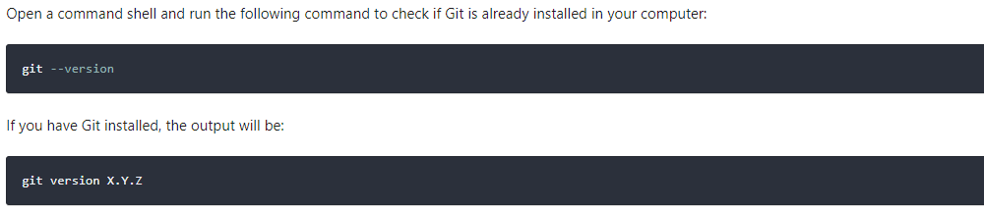

1. Now you will need to get the files from the gitlab onto the computer. The method do to this is through the git you just installed. So basically, open cmd and go to wherever you want to download all these files to. For example this is where I will do it:

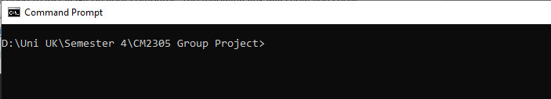

Then type: >git clone <https://git.cardiff.ac.uk/c1985846/group-4-cm2305.git>

Now you will notice a new folder called “group-4-cm2305”

1. Next is to set up your virtual environment (venv). Now you might ask what is this venv stuff. Basically, when you download other libraries it puts them all in a folder and your computer won’t be filled with useless stuff you may never use again.

So, go into the newly cloned folder

>cd group-4-cm2305

Then to set up venv:

>py -m venv venv

If that doesn’t work try:  
>python -m venv venv

Then activate the venv:

>venv\Scripts\activate

*note to deactivate just do: >venv\Scripts\deactivate

1. Now you will need to install all the needed libraries which are present in the “requirements.txt” file.

To do this write:

>py -m pip install -r requirements.txt

1. Basically, now you have flask and the rest of the stuff you will need. Now I created a file called run.py basically this will be the main thing flask needs to know about to start. So just type: >set FLASK_APP=run
2. Also to enable debug mode just write:

>set FLASK_DEBUG=”1”

1. Finally to start the development server, type:

>flask run

Which should show you something like this: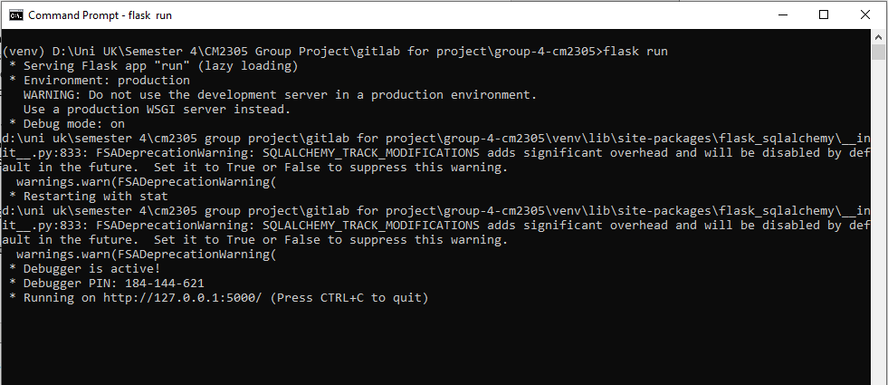

Now just type that (http://127.0.0.1:5000) into any browser url field and you should see the website working.